INTERNATIONAL
FESTIVAL OF OWLS
Concessions – Saturday 10-3
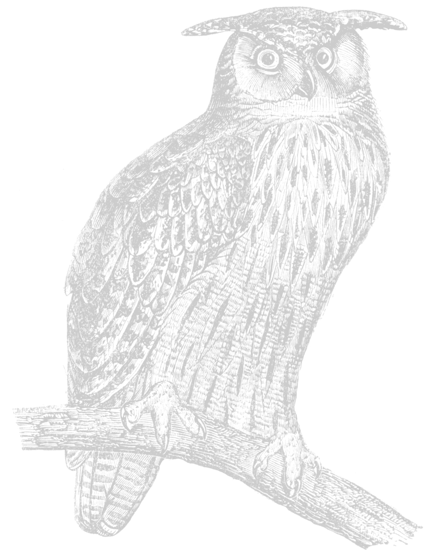
Sunday 10-1 High School Cafeteria
Proceeds go to Houston High School Band Members

- Snowy Owl Chicken Salad Croissant Meal $8.00
W/ chips, drink & cookie.
- Burrowing Owl Beef Burger Meal $8.00
W/ chips, drink & cookie.
- Barred Owl BBQ Meal $6.00
W/ chips, drink & cookie.
- Great Horned Owl Hot Dog Meal $5.00
W/ chips, drink & cookie.

Chicken Salad Croissant $5.00
Beef Burger $5.00
BBQ $3.00
Coney Dog $3.00
Hot Dog $2.50
Chips, Cookie, Danish $1.00
Whole Pickle $1.00
Pop, Water $1.50
Juice $1.50
Coffee $1.00
Pop Choices

Coke
Diet Coke
Root Beer
Mountain Dew
Diet Dew
Sprite
Orange

